Session 1 - 1

public class Solution {
public int maxSubArray(int[] nums) {
int maxSum = nums[0];
int currentSum = nums[0];

for (int i = 1; i < nums.length; i++) {
currentSum = Math.max(nums[i], currentSum + nums[i]);

maxSum = Math.max(maxSum, currentSum);
}

return maxSum;
}
}
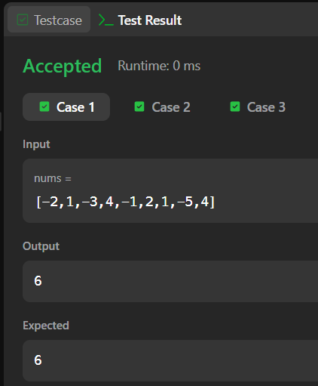

Session 1 -2

import java.io.*;
import java.util.*;
import java.util.stream.*;
import static java.util.stream.Collectors.toList;
public class Solution {

public static int birthday(List<Integer> s, int d, int m) {
if (s.size() < m) {
return 0;
}
int count = 0;
int currentSum = 0;

for (int i = 0; i < m; i++) {
currentSum += s.get(i);
}

if (currentSum == d) {
count++;
}

for (int i = m; i < s.size(); i++) {
currentSum += s.get(i) - s.get(i - m);
if (currentSum == d) {
count++;
}
}
return count;
}
public static void main(String[] args) throws IOException {
BufferedReader bufferedReader = new BufferedReader(new InputStreamReader(System.in));
BufferedWriter bufferedWriter = new BufferedWriter(new OutputStreamWriter(System.out));

int n = Integer.parseInt(bufferedReader.readLine().trim());

List<Integer> s = Stream.of(bufferedReader.readLine().replaceAll("\\s+$", "").split(" "))
.map(Integer::parseInt)
.collect(toList());

String[] firstMultipleInput = bufferedReader.readLine().replaceAll("\\s+$", "").split(" ");
int d = Integer.parseInt(firstMultipleInput[0]);
int m = Integer.parseInt(firstMultipleInput[1]);

int result = birthday(s, d, m);

bufferedWriter.write(String.valueOf(result));
bufferedWriter.newLine();

bufferedReader.close();
bufferedWriter.close();
}
}

